University of Colorado

Department of Aerospace Engineering Sciences

Manual Flight Test

12 December 2014

Drones Versus Zombies (DVZ)

Change Summary

|  |  |  |
| --- | --- | --- |
| Revision | Description of Changes | Date Released |
| - | Initial Release | 2 December 2014 |
| Rev A | Power up and arming | 3 December 2014 |
| Rev B | Edits from Matt | 12 December 2014 |
| Rev C | Launching AMCL | 12 December 2014 |

**Team Contact Information**

|  |  |
| --- | --- |
| Eric Frew  Project Advisor  Email: [e](mailto:garrett.a.brown@colorado.edu)ric.frew@colorado.edu | Nisar Ahmed  Project Customer  Email: [nisar.ahmed@colorado.edu](mailto:nisar.ahmed@colorado.edu) |
| Garrett Brown  Project Manager  Cell: (970) 210-8890  Email: [garrett.a.brown@colorado.edu](mailto:garrett.a.brown@colorado.edu) | Edward Scott  Systems Engineer  Cell: (720) 323-9857  Email: [Edward.scott@colorado.edu](mailto:Edward.scott@colorado.edu) |
| Benjamin Zatz  Test Lead  Cell: (408) 429-9174  Email: [Benjamin.Zatz@colorado.edu](mailto:Benjamin.Zatz@colorado.edu) |  |

# Description

This test will encompass manual flight performed by James Mack in the Engineering Center Hallway located on the first basement of the Aerospace Engineering Wing. The flight will take place for at least 10 minutes to ensure that there will be enough power for autonomous flight. All sensors will be functioning and AMCL will be calculating the state of the drone. Additionally this opportunity will serve to solidify the safety considerations that have been put in place. The next test is scheduled for December 18th at 5 pm and will last until 7 pm.

# Location and Equipment

## Location

The test will take place in the hallway on the second basement level of the Engineering Center that exists directly before the Aerospace Engineering Wing begins. This area spans from the main entrance of the Lockheed Martin Conference room to the loading dock at the far end of the hallway. The flight will take place completely indoors and all adjourning doors will be closed at this time.

## Equipment

* 3DR X8 Quad
* 3S Battery (Charged)
* Hokuyo Laser Scanner
* PX4 Flow Sensor
* Pixhawk
* Odriod
* Odriod Wifi Dongle
* Camera Simulated Mass
* Blade Guards
* Ground Station Computer
* Drone Cart

Bathroom Entrance

Outside Entrance

Outside Entrance

Visions Hallway

Loading Dock

Stairway

Stairway

Lockheed Martin

* Protective gear
* RC controller

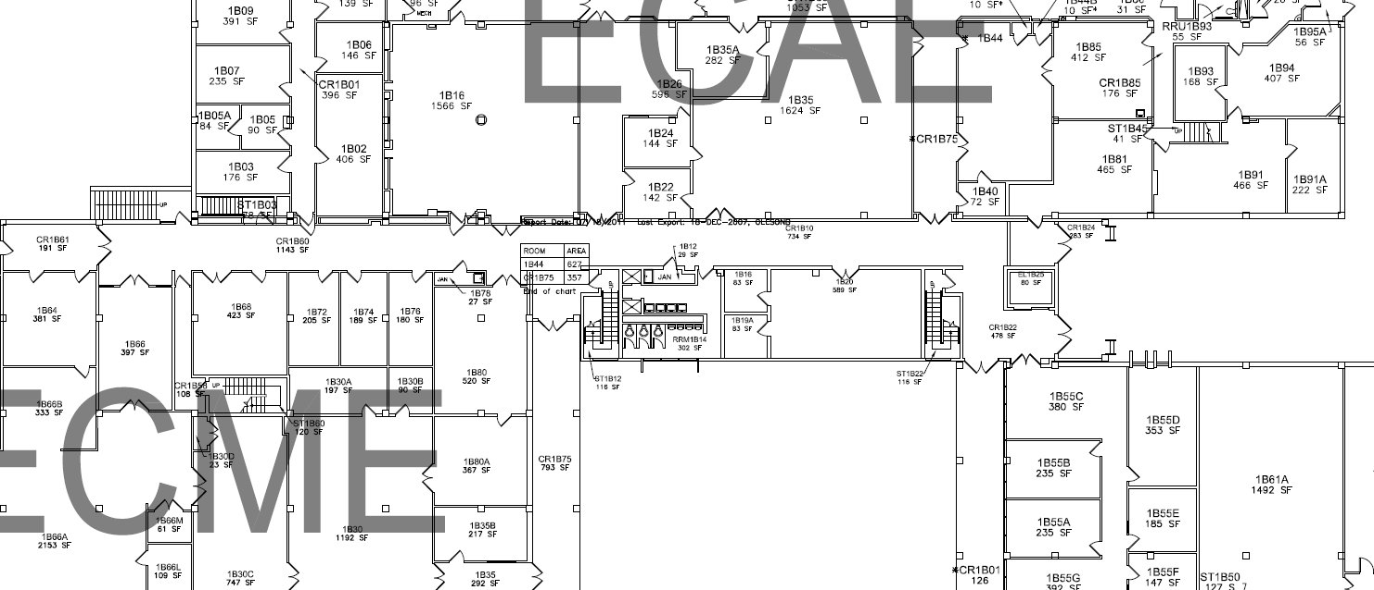

# Setup

## Assumptions

### All equipment is installed on the drone (PX4 Flow, Hokuyo, Camera mass, Odriod, ect.)

### No elements of the drone are damaged

### The correct gains have already been applied

### Full link and lost link safety measures have been tested

### Map of flight space has already been created

### Bystanders directly affected by the test have been notified prior about test date and times

### Building safety has been fully evaluated

### Necessary stakeholders have been contacted about test date and time

### Test location has been examined for any prior damage

## Drone

### Power on ground station

### Test network connection

### Upload the map to the ground station.

### Run GUI on ground station

### Start with only the Wifi Dongle connected to the Odriod

### Connect power to the Odriod

### Connect power to the USB hub

### Connect USB cable from Hokuyo to USB hub

### Connect USB cable from PX4 Flow to USB hub

### Connect USB cable from Pixhawk to USB hub

### Connect the battery to the BEC

### Wait for chime from Pixhawk to confirm preflight check list completed

### Connect USB hub to Odriod

### Attach Drone to the cart

### On ground station open a terminal and type ***roscore***

### Open a new tab (Ctrl+Shift+t) and type ***rviz***

### Open a new tab (Ctrl+Shift+t) and type ***rosrun map_server map_server [mymap.yaml]***

### In RVIZ window, expand map options, set topic to /map

### On a new terminal, type ***wolverine***, password ***odroid***

### Type ***px4flow_launch***

### Open a new tab (Ctrl+Shift+t), type ***wolverine***, password ***odroid***

### Type ***pixhawk_launch***

### Open a new tab (Ctrl+Shift+t), type ***wolverine***, password ***odroid***

### Type ***hokuyo_launch***

### Open a new tab (Ctrl+Shift+t), type ***wolverine***, password ***odroid***

### Type ***roscd odometry/scripts***

### Type ***./pub_odom.py***

### Open a new tab (Ctrl+Shift+t), type ***wolverine***, password ***odroid***

### Type ***roslaunch amcl dvz_amcl_test.launch***

### In RVIZ, click add, then select Pose Array

### Expand Pose Array options, set topic to particle cloud

### In RVIZ window, click 2D Pose Estimate

### On map click on initial [x,y] position and drag to set initial yaw

### Perform simple movements with the cart and observe data

### Disconnect drone from cart

### Perform a simple hover maneuver with the RC controller

# Procedure

### Examine the test location for any changes in safety

### Place drone at one end of the hallway

### Position team members throughout the hallway at main access points

### One team member should have safety equipment within arm’s reach

### Final sweep is performed by test lead to confirm the absence of bystanders

### Power on the RC controller

### Set flight mode switch to Stabilize

### To arm the drone, hold the safety button on the Pixhawk until the light goes from flashing to solid

### Wait for beep from Pixhawk

### On the RC controller, hold the throttle stick in the bottom right corner for 5 seconds

### At this point the flight system is armed

### Begin flight with a simple hover maneuver followed by landing

### Flight in simple straight line paths

### Duration of flight should last for at least 10 minutes

### At termination of flight, return the RC controller to Stabilize

### On the RC controller, hold the throttle stick in the bottom left corner for 2 seconds

### Pixhawk LED will start flashing green

### On PX4 Flow press safety button until light starts flashing

### Disconnect battery from BEC

# Results

State data calculated by AMCL will be evaluated for inconsistencies.